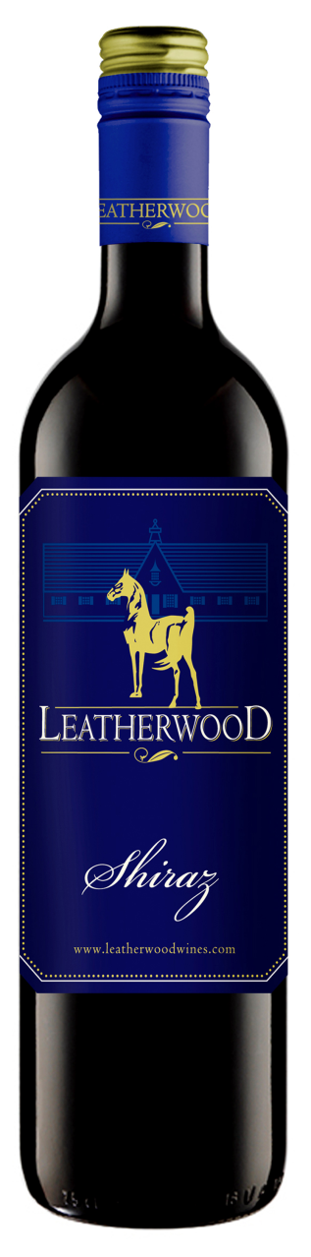
Leatherwood Shiraz 2014

Blend: 100% Shiraz
Winemaker : Chris de Wet
Alcohol : 14.5% vol
RS : 5 g/l
Total Acid : 5.04 g/l
Brix : 25°
Yield : 5.2 tons/acre
Production : 12,000 cases
Oak Type : French Barriques
Oak Age : 100% 2nd fill
Time in Oak : 12 months
Appellation : Western Cape, South Africa
Harvest date : 2/20/2014

Beverage Testing Institute Ratings:
“Bright dark garnet violet color. Smoky, complex aromas and flavors of smoky blackberries, mocha, pomegranate, and toasty oak with a tannic, crisp, dry full body and an intricate, medium-long finish with fine tannins”
- World Wine Championships Award: Silver Medal
- Rating: 88 points (Highly Recommended)

Vineyard Varieties
Dublin, VA

