Leatherwood Sauvignon Blanc’17
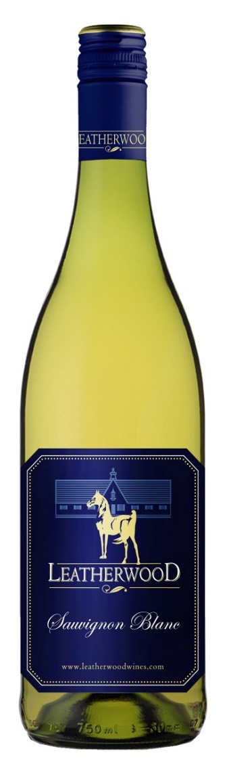
Technical Analysis
Blend: 100% Sauvignon Blanc
Winemaker: Chris de Wet
Appellation: Western Cape, South Africa
Yield: 10 tons/acre
Harvested: 2/28/2017
Production: 10,000 cases
Aging: 100% Steel Tank
Brix: 22
Alc 13.0
Ph: 3.04
RS: 3.7 gr/L
TA: 7.2
Tasting Notes:
Sauvignon Blanc vines thrive in our deep alluvial soils, typically leading to a lingering mineral aftertaste. On the nose you will find passion fruit and ripe fig aromas. The palate is intense and the refreshing acidity provides structure and balance.
2017 WORLD WINE CHAMPIONSHIPS AWARD: Silver Medal

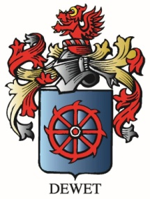

www.vineyardvarieties.com

