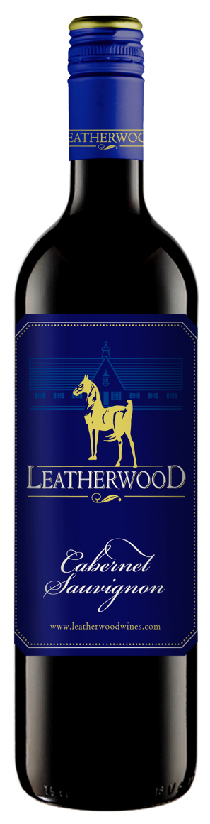
Leatherwood
2015 Cabernet Sauvignon
Blend: 100% Cab Sauv.
Winemaker : Chris de Wet
Alcohol : 14% vol
RS : 2.5 g/l
Total Acid : 5.6 g/l
Brix : 26.3°
Yield : 8 tons/acre
Production : 18,000 cases
Oak Type : French Barriques
Oak Age : 80% 2nd fill; 20% new
Time in Oak : 12 months
Harvested: 3/8/2015
Appellation : Western Cape, South Africa
Beverage Testing Institute Ratings:
Bright dark garnet violet color. Complex aromas and flavors of cassis, red flowers and spring water, charcoal wood smoke with a tannic, crisp, dry full body and a warming, complex, medium-long finish with firm tannins and moderate oak.
--2015 World Wine Challenge GOLD Medal.
-- Rating: 90 points [ Highly Recommended]
--2012 World Value Wine Challenge Best South African Cabernet Sauvignon under $20
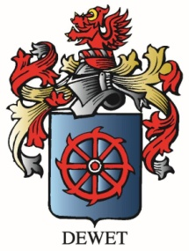

www.vineyardvarieties.com

